**Lake Park Technology Guide**

## Table of Contents

Introduction ................................................................................................................................................ 1

Website Navigation Basics .......................................................................................................................... 2

End-User Website Navigation Elements ................................................................................................. 2 MyStart Bar ......................................................................................................................................... 2

Channel Bar ......................................................................................................................................... 3

Site Structure and Navigation ................................................................................................................. 4

Getting Started ............................................................................................................................................ 5 Sign In ...................................................................................................................................................... 5

My Account ............................................................................................................................................. 6

Edit Account Settings .......................................................................................................................... 7

Sign Out ............................................................................................................................................... 7 District Home Button .............................................................................................................................. 7

Select a School ........................................................................................................................................ 7

Site Manager ........................................................................................................................................... 7

Editing Privileges ......................................................................................................................................... 9 Site Director ............................................................................................................................................ 9

Subsite Director ...................................................................................................................................... 9

Homepage Editor .................................................................................................................................... 9

Channel Director ..................................................................................................................................... 9

Section Editor .......................................................................................................................................... 9

Navigating Site Manager .......................................................................................................................... 10

Site Manager Links ............................................................................................................................... 10

Content Browser ....................................................................................................................................... 11 Off Canvas Menu ................................................................................................................................... 12

Site Fly Out Menu ................................................................................................................................. 13

Section Fly Out Menu ............................................................................................................................ 14 Administrative Workspaces ...................................................................................................................... 15

Users & Groups Workspaces ..................................................................................................................... 16

Users Workspace .................................................................................................................................. 17 Users Tab .......................................................................................................................................... 17

Passports Tab .................................................................................................................................... 18

Import Users Tab .............................................................................................................................. 18

Update Users Tab .............................................................................................................................. 18

Import Family Relationships ............................................................................................................. 19

Recycle Bin ........................................................................................................................................ 19

Groups Workspace ................................................................................................................................ 20 Groups Tab ........................................................................................................................................ 20

Categories Tab .................................................................................................................................. 20

Importing Groups Tab ....................................................................................................................... 21

Mass Assign Users Tab ...................................................................................................................... 21

**i**

## Introduction

Welcome and congratulations! You are about to learn how to become an active and integral contributor to your Blackboard Web Community Managerwebsite.

This guide provides you with what you need to know to become a Site Administrator. You will find information about your websiteas well as instructions for common tasks you may need to perform as a Site Administrator.

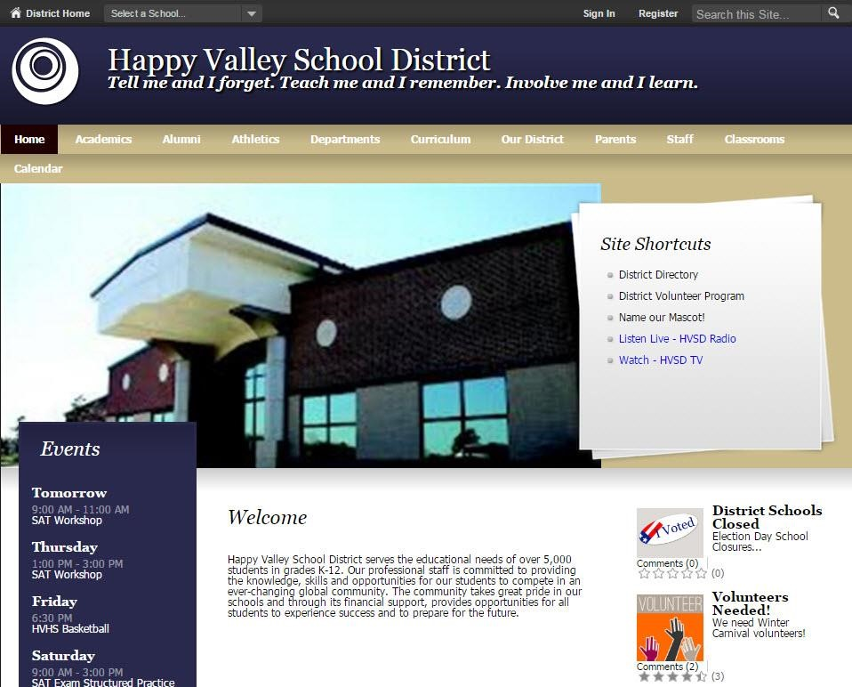

## Website Navigation Basics

Site Administrators, Site Directors and Subsite Directors should be familiar with the structure of the website.

### End-User Website Navigation Elements

These navigation elements display on every page of the end-user website.

* MyStart Bar
* Organization Name

•

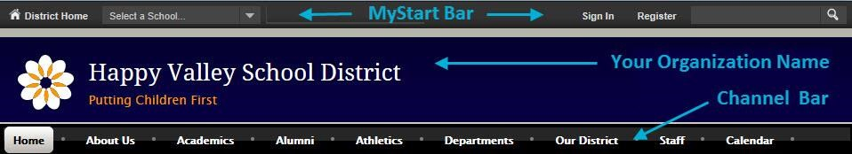

#### MyStart Bar

General navigation elements appear on the MyStart navigation bar of Web Community Manager.

However, what you see before you sign in and what you see after you sign in will be slightly different.

Prior to signing in, the following navigation elements may be available to you on the MyStart bar before you sign in.

* Select a School—This drop-down list allows you to navigate to your subsites.
* Sign In—This allows registered users to sign in to the site and access their user accounts.
* Register—This allows visitors to create a user account for themselves by self-registering.
* Grades—This is an optional feature used to link to a separate grading program. • Email—This is an optional feature used to link to a separate Email program.

After signing in, the following navigation elements may be available to you after you sign in.

* Site Manager—This link allows you to edit areas of the website to which you have been assigned.
* My Account—This link provides access to account options.
* Edit Account Settings—Click this option to access your account information and modify it.
* Sign Out—Click this option to sign out of the site. We always recommend that you sign out when you are finished working.
* My PassKeys—This link allows access to your library of single sign-on PassKeys which provide secure access to web applications through Web Community Manager.

#### Channel Bar

Channels are visible on every page of your site or subsite. They provide visitors to your website with consistent navigation throughout the site or subsite. The channels on each subsite may be different from those on the main site or other subsites.

Channels contain sections and within each of those sections are pages of information about that particular section. Think of your website as a filing cabinet of information.

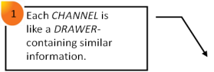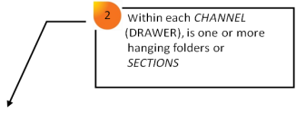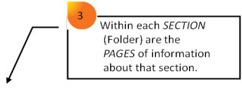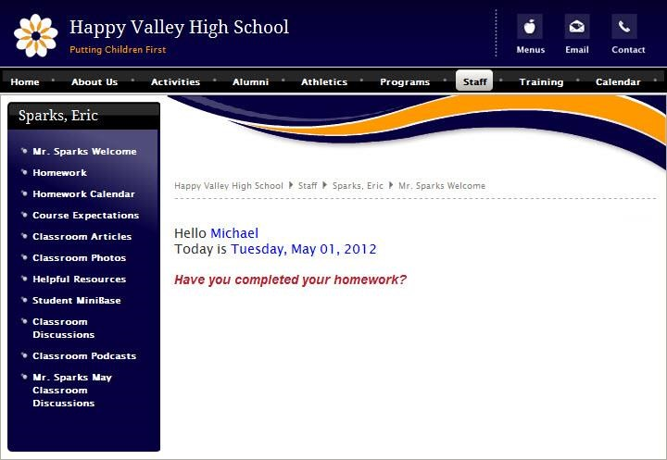

Web Community Manager allows you to have channel homepages and channel calendars. If you choose to enable these, you can provide visitors with an overview of what they will find within your channel. You may also choose to have a directory page, or just set the channel to automatically direct website visitors to the first Section in the channel when they click the name.

### Site Structure and Navigation

Web Community Manager provides visitors to your website with consistent channel navigation. Notice the two sections within the Parents channel, *PTO* and *Parent Handbook.*

When you select the PTO section on the Parents channel drop-down, you are taken to the landing page of that section, *Definitions*. From there you can navigate to the other pages within that section by clicking the *Volunteer!* or *PTO Calendar* pages. You can also use the channel bar and choose a different channel on that site or use *Select a School* on the MyStart bar to navigate to one of your other sites.

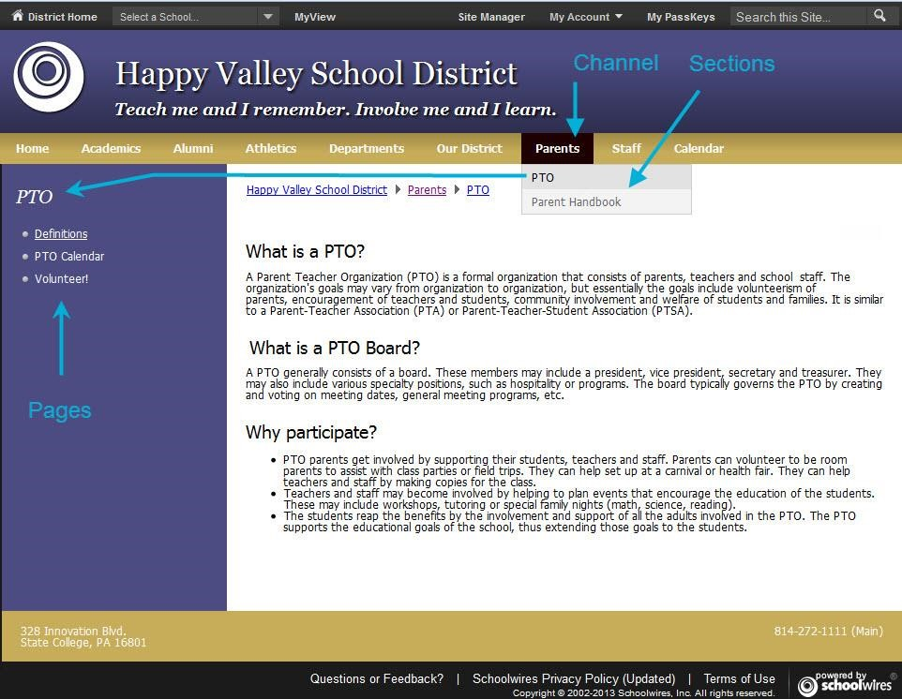

## Getting Started

If you have a user name and a password, you can sign in to the website. You can also edit your My Account settings.

### Sign In

Here’s how you sign in to the website.

1. Open your web browser. Enter the web address (URL) for your website. If you are developing your website, your URL will be in the format *http://YOURSITE.blackboard.net.* When your website is live, the URL will be the domain name that you have provided to Blackboard.
2. Click **Sign In** on the MyStart bar. A sign in window displays.



1. Enter your User Name and Password. Passwords are case-sensitive.

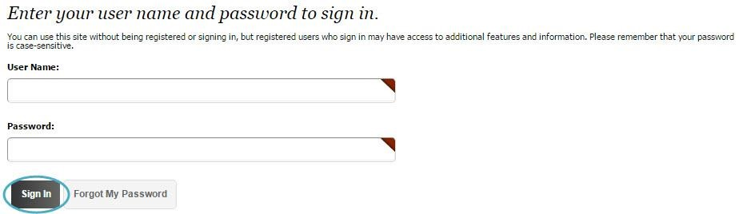

1. Click **Sign In**. Your User Name and Password are authenticated and if correct, you are signed into the website.

If you forget your password, click **Forgot My Password**. A link you use to reset your password is sent to the Email address entered in your User Account settings.

### My Account

After signing in, **My Account** displays on the MyStart bar. From here you sign out of the website and edit your My Account settings.

In the Edit Account Settings dialog, you will see the **Information**, **Subscriptions**, **PassKey Accounts**, if it is active for your site, **Change Password** and **Delete Account** tabs.

The **Information** tab includesfields such as user name, email address, first name, last name, title, phone number and mailing address. Be sure to enter your zip code as it is used to calculate distances to event locations. You can also select an avatar here if you like.

The **Subscriptions** tab is where you can subscribe to receive notifications when updates are made to homepages and sections on your site and subsites.

The **PassKey Accounts** tab is where you can set up your PassKeys.

The **Change Password** tab allows you to change your password. Passwords should be at least seven characters in length with a maximum number of 50 characters. They should include alpha and numeric characters.

The **Delete Account** tab allows you to delete your account.

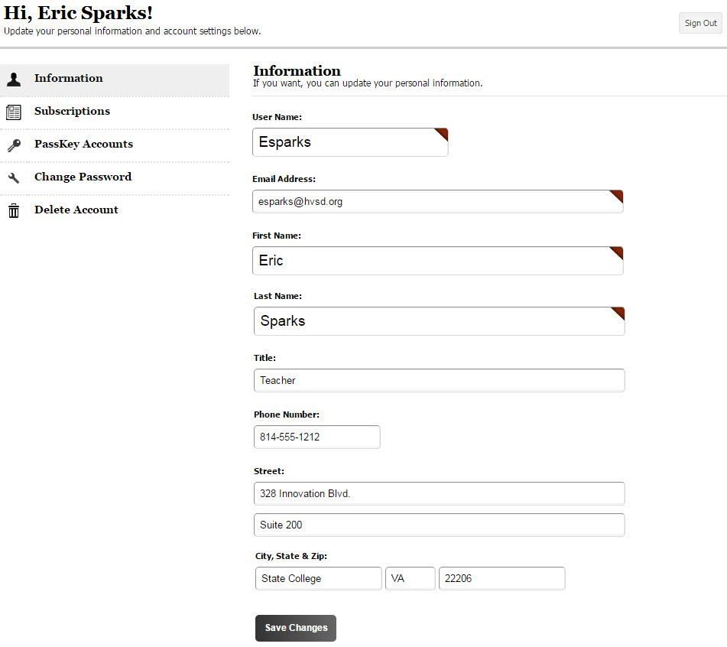

#### Edit Account Settings

Here’s how you edit your account settings.

1. Select Edit Account Settings from the My Account drop-down list. The Edit Account Settings dialog displays on the **Information** tab.

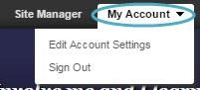

1. Edit your account as desired. Fields marked with red triangles are mandatory and must be completed.
2. Once finished, click **Save**.

**Sign Out**

To sign out, click **My Account** and select *Sign Out* from the drop-down.

homepages, read [Manage Site and Subsite Homepages.](http://insight.dev.schoolwires.com/HelpAssets/C2Assets/C2Guides/WCMHomepages.pdf)